How to use MSA logo in Circuitmaker

The MSA logo has been installed as a true-type font on this Windows machine.

It was installed by following instructions at: <https://circuitmaker.com/blog/adding-custom-logos-to-pcbs>

To use this font, follow the image

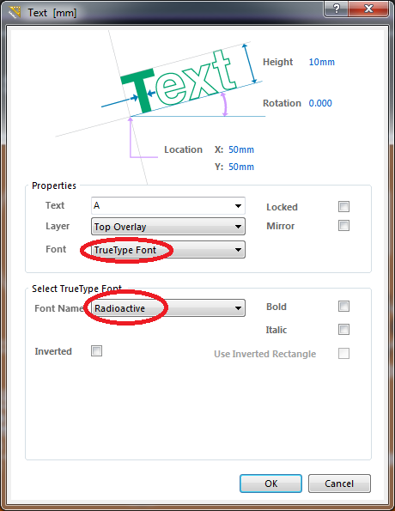

However, set “Font Name” to “msalogo”. The letter “A” (as capital) is the logo, all letters are the default letters.